Experiment Name: Configuring Router using RIP routing technique
Objective
The main objective of this experiment was to design, implement, and configure a tri-router based network using Cisco Packet Tracer with the RIP (Routing Information Protocol) as the dynamic routing mechanism. In this network design, three routers were interconnected in a triangular topology, allowing multiple possible paths for data transmission between the networks. Each router was responsible for connecting and managing one local area network (LAN) through a dedicated switch. A total of six personal computers were used in the experiment and were evenly distributed across the three switches, with two PCs connected to each switch. Every PC was manually assigned an IP address according to the subnet of its corresponding LAN to ensure proper network communication. The primary goal of this setup was to achieve complete end-to-end connectivity among all the subnets by utilizing the dynamic routing capabilities of the RIP protocol, allowing automatic route discovery and information exchange between all routers in the network.
Introduction
Routers make forwarding decisions using routing tables. When routing is configured dynamically using RIP, routers automatically exchange routing information with neighboring routers. RIP is a distance-vector routing protocol that uses hop count as its routing metric. It allows routers to learn routes dynamically without manual configuration. In this experiment, RIP (Routing Information Protocol) was used to interconnect three LANs through three routers in a triangular topology, ensuring automatic route learning and communication between all end devices.
Required Devices
- Three Cisco 1841 routers
- Three Cisco 2960 switches
- Six PCs
- Straight-through cables for LAN links
- Serial DTE/DCE cables for router-to-router links
Procedure
Step 1: Placing all required devices
All routers, switches, and PCs were placed into the Cisco Packet Tracer workspace to build the network topology. Each LAN consisted of one switch and two PCs, and every switch was directly connected to a single router to enable local and inter-network communication.
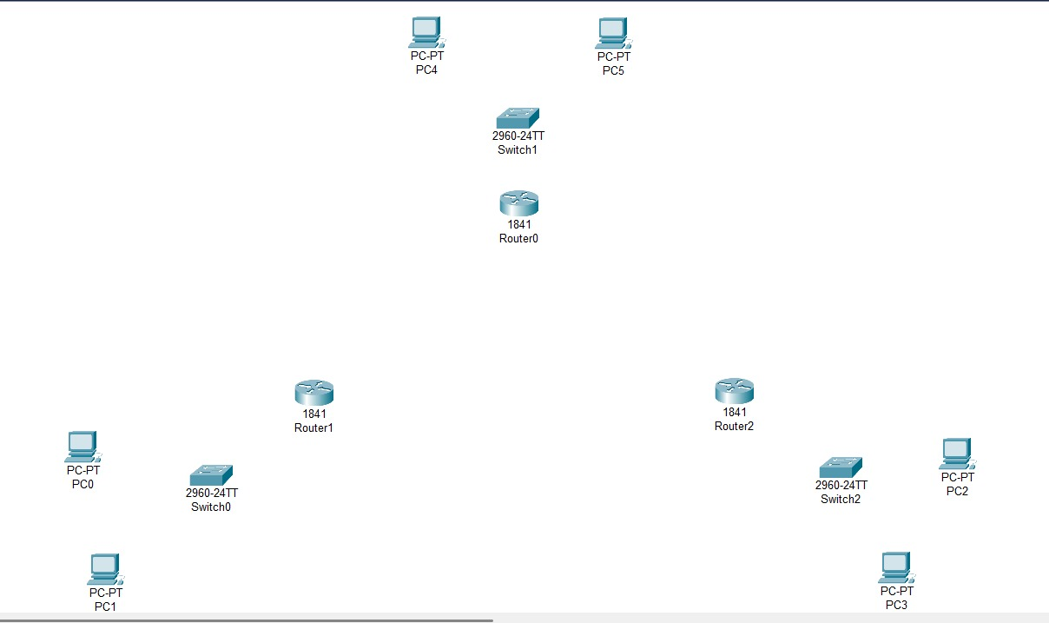
Figure 6.1: Placing all the devices in the workstation
Step 2: Making the physical connections
Straight-through cables were used to connect PCs to switches and switches to routers. As back-to-back router connections require serial interfaces, Serial DTE cables used to connect Three routers in a triangular manner.
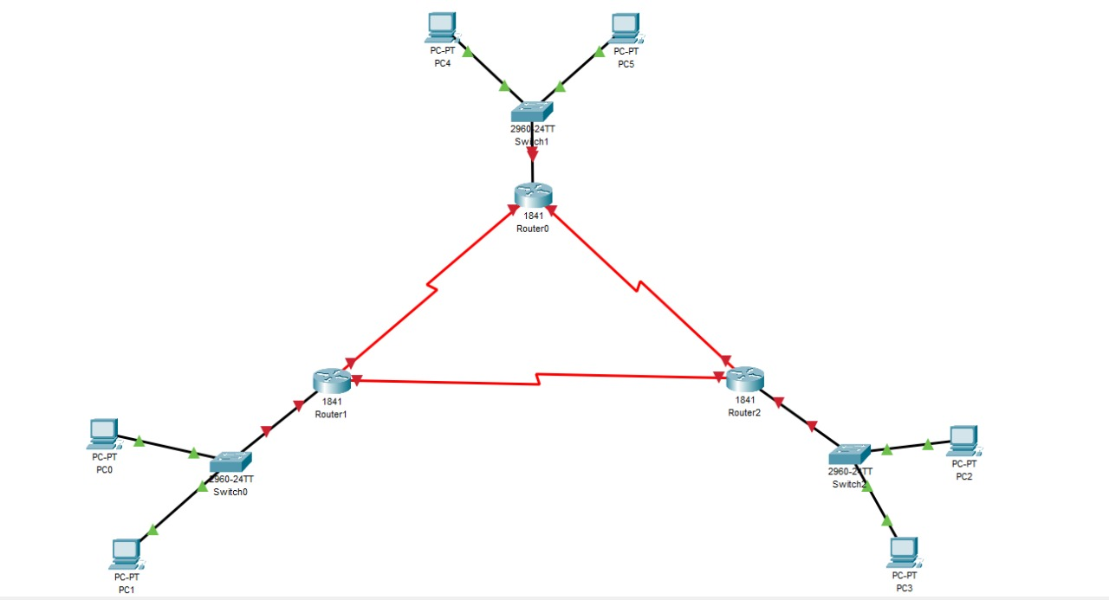
Figure 6.2: Connecting the devices
Step 3: Assigning IP addresses to the PCs
Each PC was assigned an IP address and default gateway according to its LAN. The gateway corresponds to the FastEthernet0/0 interface of the connected router.
PC IP Address - Gateway
PC0 192.168.1.2 - 192.168.1.1
PC1 192.168.1.3 - 192.168.1.1
PC2 192.168.3.2 - 192.168.3.1
PC3 192.168.3.3 - 192.168.3.1
PC4 192.168.2.2 - 192.168.2.1
PC5 192.168.2.3 - 192.168.2.1
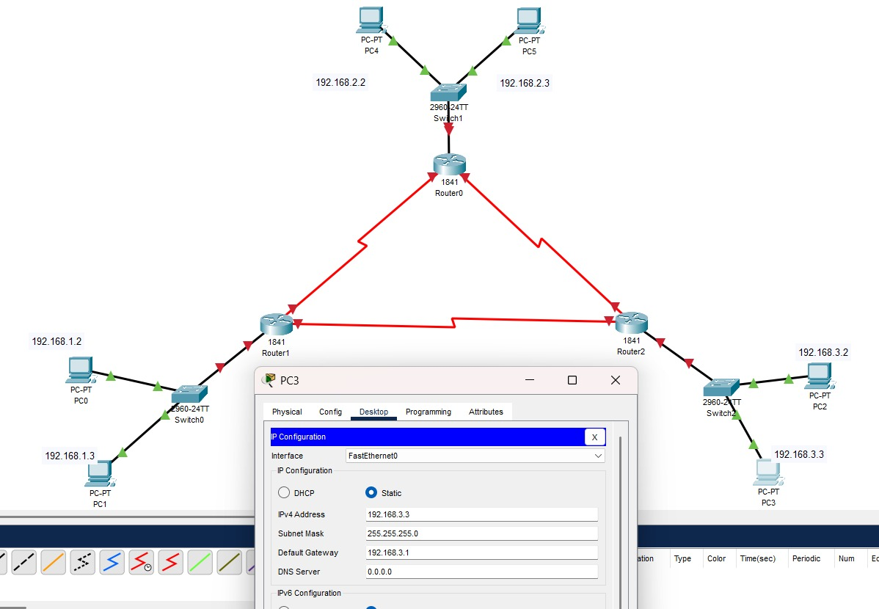
Figure 6.3: Assigning IP Address to PCs

Step 4: Adding serial ports to routers
Since Cisco 1841 routers do not come with built-in serial ports, WIC-2T modules were inserted. Each router was powered off, the module was added from the Physical tab, and then the router was powered on again to activate the serial interfaces.
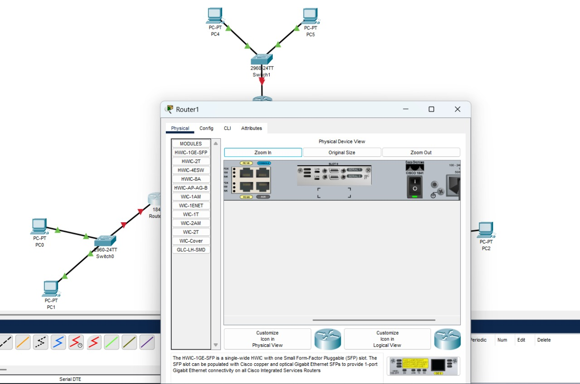
Figure 6.4: Adding Serial ports to routers
Step 5: Configuring router interfaces
The FastEthernet0/0 interface on each router was configured with its LAN gateway address, while the serial interfaces were assigned IPv4 addresses to form point-to-point links.
Configuring Router IPV4 Adresses:
- Router0:
  - FastEthernet0/0 → 192.168.2.1
  - Serial0/0 → 11.0.0.3
  - Serial0/1 → 12.0.0.3
- Router1:
  - FastEthernet0/0 → 192.168.1.1
  - Serial0/0 → 10.0.0.2
  - Serial0/1 → 11.0.0.2
- Router2:
  - FastEthernet0/0 → 192.168.3.1
  - Serial0/0 → 10.0.0.3
  - Serial0/1 → 12.0.0.2
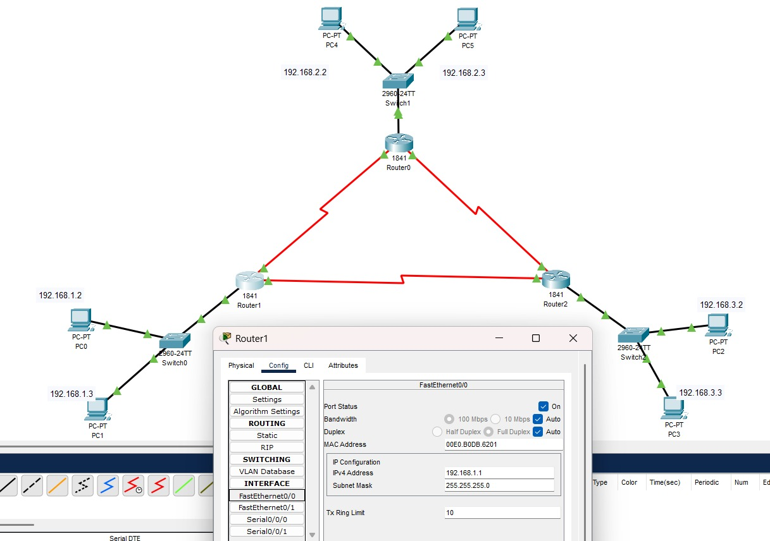
Figure 6.5: Configuring The Router Interfaces
Step 6: Configuring RIP routes on all routers
RIP Version 2 was enabled on each router. All directly connected networks were advertised using the network command so that routers could automatically learn routes.
RIP Route Configuration
Router0 Networks
- 192.168.1.0
- 192.168.2.0
- 192.168.3.0
- 11.0.0.0
- 12.0.0.0
Router1
- 192.168.1.0
- 192.168.2.0
- 192.168.3.0
- 10.0.0.0
- 11.0.0.0
Router2
- 192.168.1.0
- 192.168.2.0
- 192.168.3.0
- 10.0.0.0
- 12.0.0.0
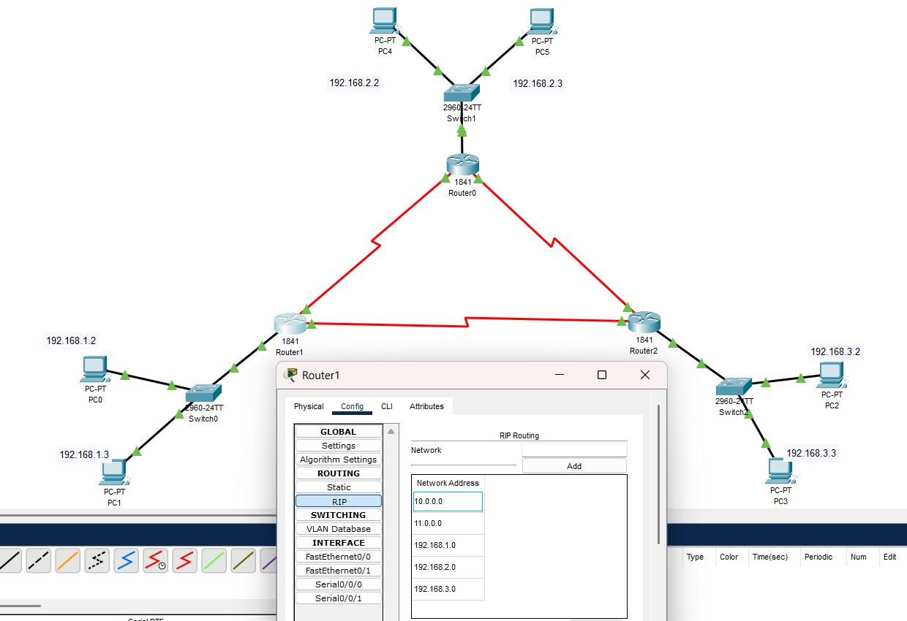
Figure 6.6: Configuring RIP Routes on each Router
Step 7: Testing Connectivity
Simple PDU messages were sent between PCs across different LANs. All test results showed successful message delivery, confirming that RIP successfully exchanged routing information and enabled full connectivity between all six PCs.
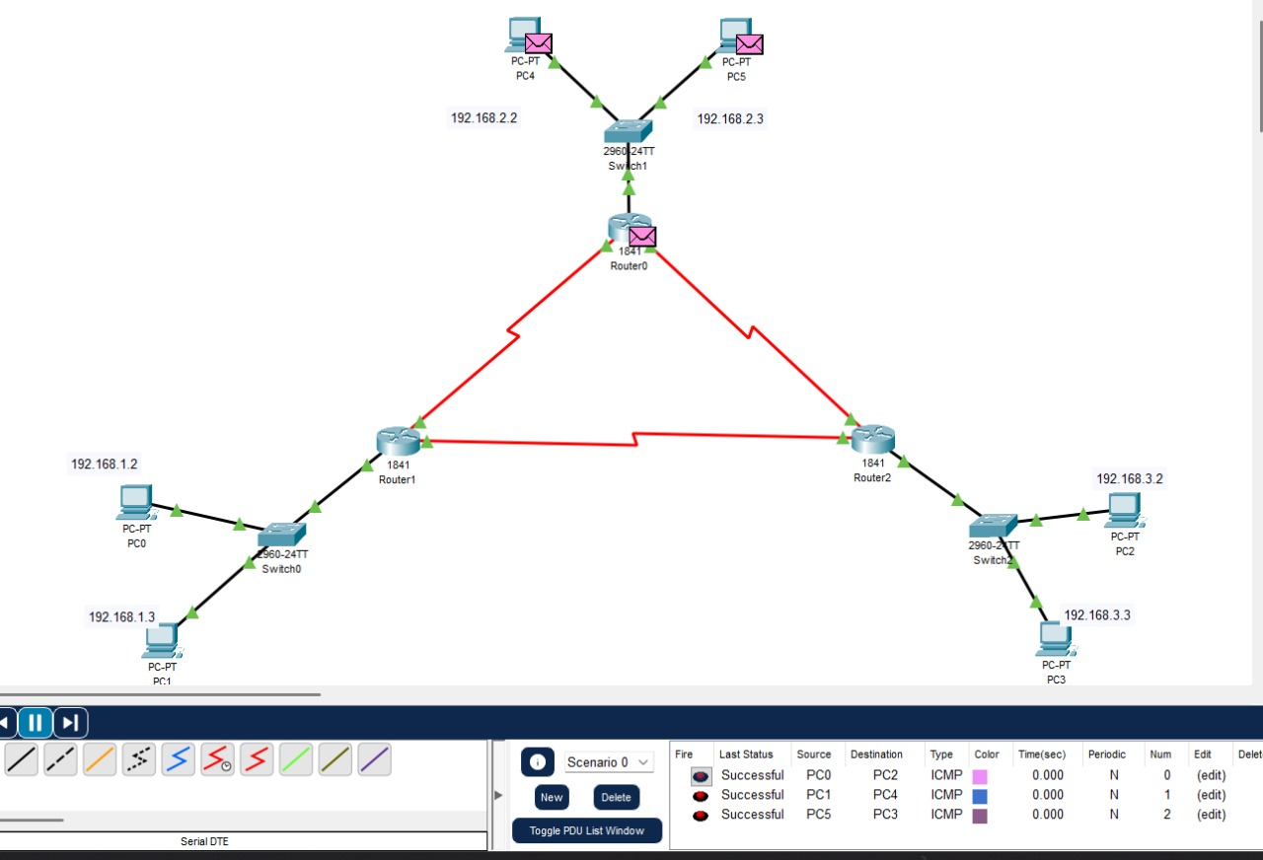
Figure 6.7: Testing The connectivity
Conclusion
This experiment demonstrated how RIP dynamic routing can be used to interconnect multiple LANs across several routers. Unlike static routing, RIP automatically learns and updates routing information through periodic exchanges. The network successfully achieved complete communication between all six PCs without manual route configuration. This experiment highlights the simplicity and efficiency of dynamic routing protocols like RIP in small and medium-sized networks.

